Airtable: My Dance Journey- Daytime as a Student; Nighttime as a Dancer



When I was little, my mother sent me to Chinese dance classes where I discovered my potential in learning movement quickly and memorizing it for decades. Since then I already know dancing means something in my life. As I grew older, my love of dance stems from the love of music; human is a complicated being, there are just emotions and messages that cannot be expressed by words, or, people are too shameful to talk about it; Therefore, dancing is my language to communicate with people around. When I am moving to the music, I enjoy feeling the energy flowing inside my blood. Every texture, every shape, every flow, is telling a unique story; is unleashing my possibilities. If you ask me why I love dancing now, I will tell you it is because I can completely release from the preoccupations and stresses of everyday life whenever I dance. This is a precious ‘me-time’ which I can have my body and mind connected. Dancing for me is absolutely a tangible and real passion that fills me with life!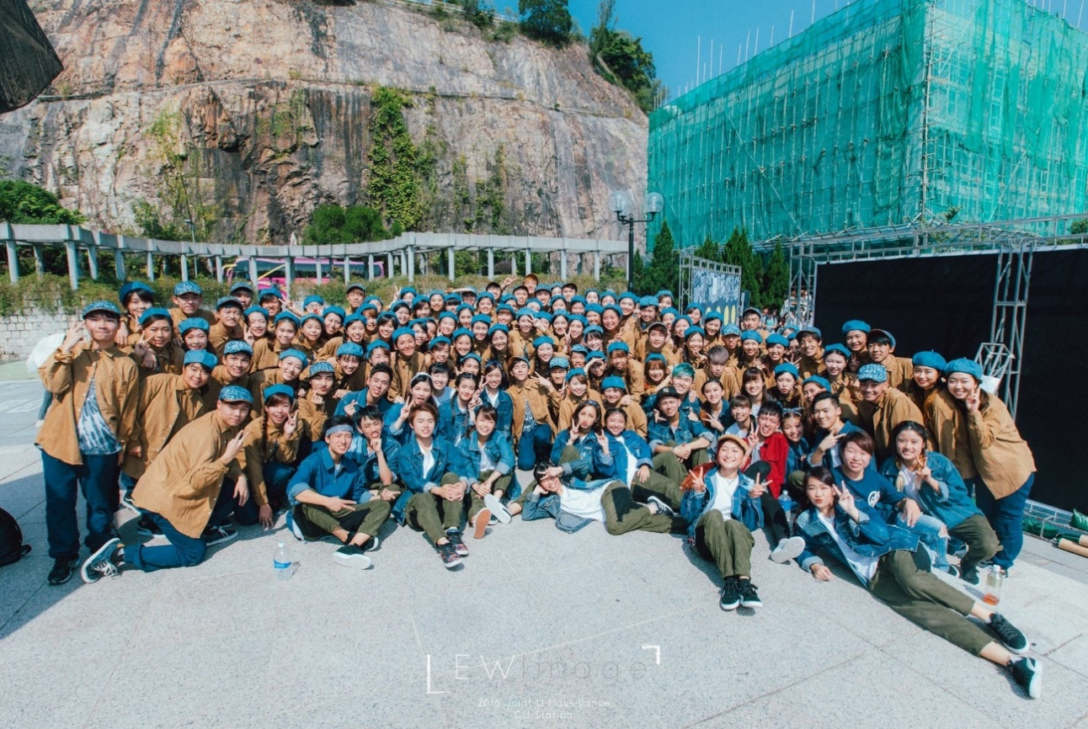

*And my LOVELY FRIENDS FOR SURE!*

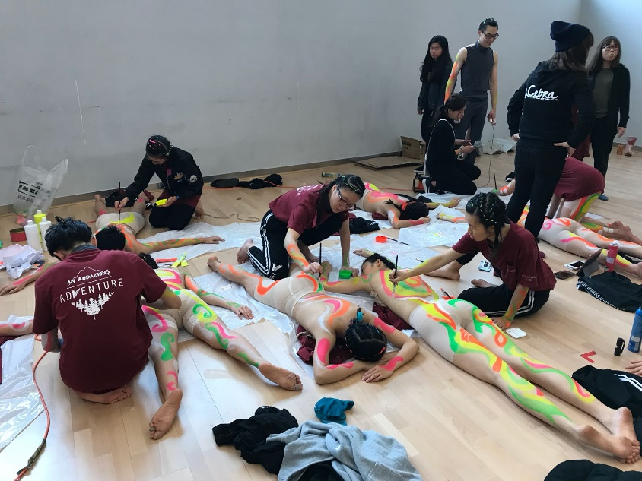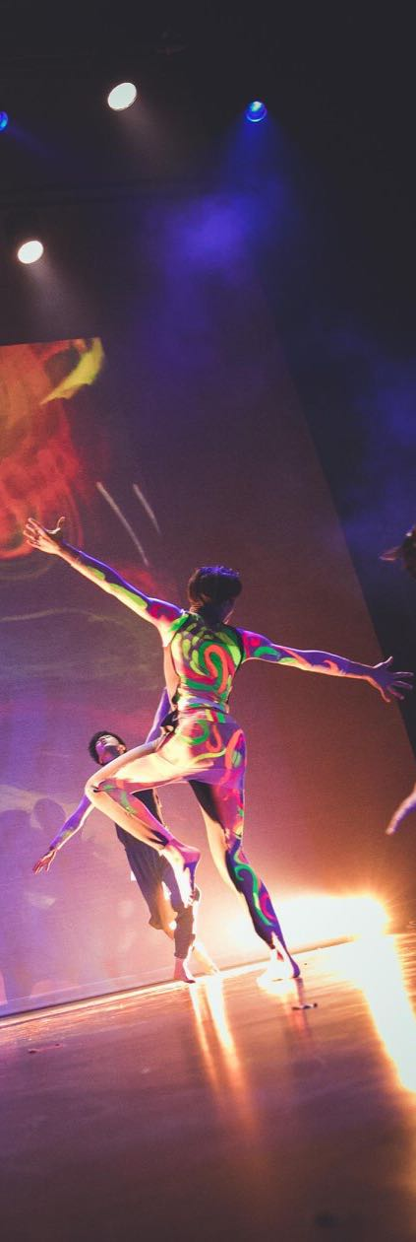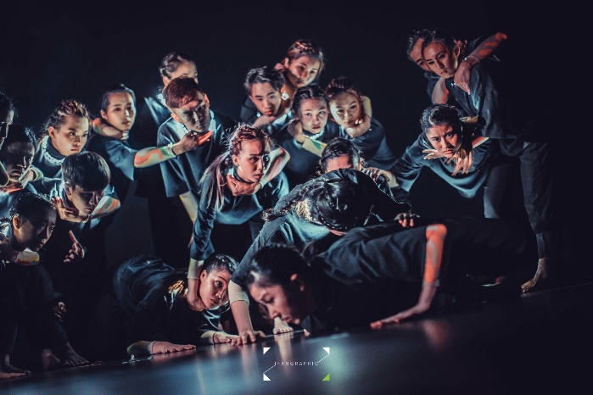I have done quite a lot of crazy things for dancing, and it kinds of shaped me into a more open-minded person. For example, back in my Year Two, I joined the Joint-U Mass Dance Show 2016 in which I participated in 10 tours to 10 universities in November. I am dare enough to say I must be the weirdest girl on campus during that on-show-month; a bright-red-curly-hair girl with heavy makeup, wearing an oversized costume rushing to classes right after show with a sweaty face! I wonder how did I have the courage to do this back in the days! And if you ask me what is the craziest costume I have ever wore, I will tell you: it is TO GO NAKED ON STAGE!!!’ In the Inter-University Dance Competition 2018, I naked my entire back body and painted it with acrylic body paint! It was a bit embarrassing at first, but after a few times of rehearsal, I am ADDICTED to this feeling as a FREE SPIRIT!

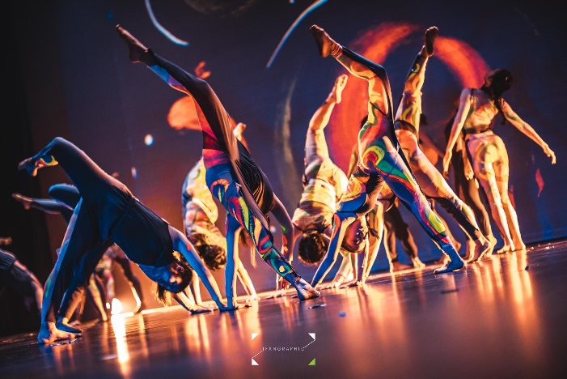

It can be a big commitment, especially when rehearsing for a performance, but if you love something, you will always try hard to achieve it! Without dance, my world would have been much narrower. I would never have met as many fascinating people as I do, never been as inspired by my crewmates and other artists, and never have felt so much alive! 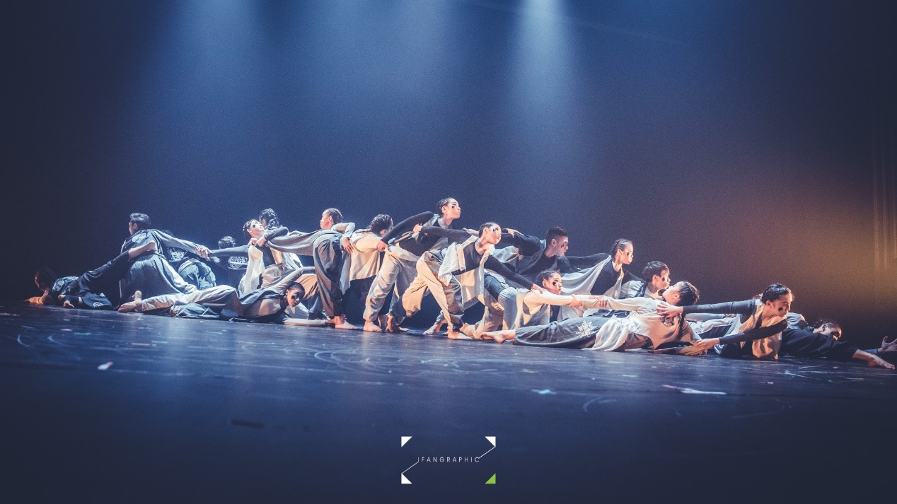

Dance studio is the second home of mine where I will go for dancing class almost five days a week; this is another half of my life, my identity as a dancer. Therefore, I am sure that it would be a fantastic idea to create a personal Dance Record on Airtable to track my footprint on the journey towards a professional dancer. This is also a good way to test the effectiveness of Airtable in relation to increasing one’s productivity! In my Airtable, I created many original templates such as course packages I signed up for, my daily training schedule, workshop log, showcase log and many more coming soon! I am going to expand my Airtable with fashion templates where I can include costume ideas! I really hope that with the help of Airtable, I can be better organized with my dance life, and assist me in pursuing my dream as a dance studio owner and spread the positive vibe of dancing to more people!

